LAB EXPERIMENT NO # 09
Name: Simran Chimrani Date: 29-March-2026
Score: ______________________Signature of Instructor___________
Voltage Divider and Current Divider Rules
PERFORMANCE OBJECTIVE:
- To verify the current divider and voltage divider rules.
- Verify measurements with calculated values.
EQUIPMENT AND COMPONENTS:
- Multimeter
- Power supply
- Connecting Leads
- Breadboard
- Few Resistors
- Ohmmeter
- Voltmeter
- Ammeter
Introduction:
Voltage Division:

Voltage Division is used to express the voltage across one of the several series resistors in terms of the voltage across the combination.

In the Circuit shown below, Voltage V is divided across the resistors R1 and R2. The Voltages across each resistor which are V1 and V2 can be determined by the Voltage division rule.

FIGURE 1
For a series combination of N series resistors,

V_{k} = (R_{k} / R₁ + R₂ + R₃ +………..+ R_{n}) V

Current Division:

Current Division is used to express the current through one of the several parallel resistors in terms of the current through the combination.

In the Circuit shown, current I is divided between the resistors R1 and R2. The currents through each resistor which are I 1 and I 2 can be determined by the current division rule.

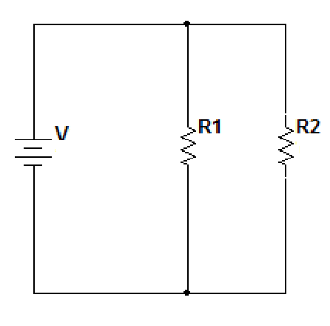
FIGURE 2
For a parallel combination of N series resistors,
I_{k}= (1/R_{k} / (1/R₁ + 1/R₂ +…….. + 1/R_{n})) I
PROCEDURE:

V = ________ R1 = ________ R2 = ________ R3 = ________ R4 = ________

For the given circuit in figure 3 verify VDR. First calculate the voltage using the formula and write them in Table 1.
Secondly measure the voltage by multimeter through R1, R2, R3, and R4. Then compare the voltages obtained by calculation to the voltages obtained by multimeter. Write them in Table 1.

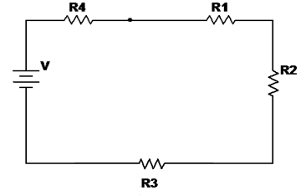

FIGURE 3
Table 1
Voltages | By VDR | By Multimeter
V1 | 1V | 1V
V2 | 1.5V | 1.5V
V3 | 4V | 4V
V4 | 5.5V | 5.5V

For the given circuit in figure 4 verify CDR. Pick the resistors from resistor tray, write their values below and measure current I for R1, R2, R3 and R4 using ammeter. Fill the Table 2 by calculating current first by CDR and then write the measured values through ammeter.

I = ________ R1 = ________ R2 = ________ R3 = ________ R4 = ________

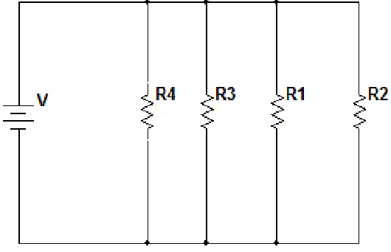

FIGURE 4
TABLE 2
Current | By CDR | By Multimeter
I1 | 0.476A | 500mA
I2 | 0.317A | 333.33mA
I3 | 0.119A | 125mA
I4 | 0.0867A | 90.09mA

CONCLUSION

Figure 1
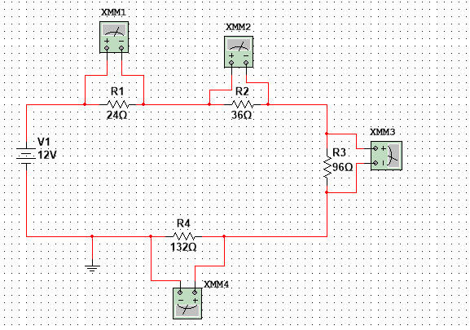
Figure 2

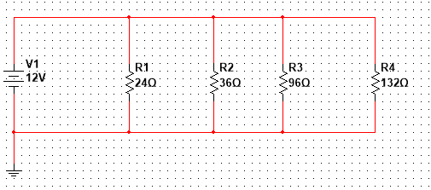

Conclusion:
This experiment successfully verified the Voltage Divider Rule (VDR) and Current Divider Rule (CDR). For Figure 3, calculated voltages using VDR (V1=1V, V2=1.5V, V3=4V, V4=5.5V) matched measured values exactly, confirming that voltage divides proportionally among series resistors. For Figure 4, CDR was validated as calculated branch currents (I1=0.476A, I2=0.317A, I3=0.119A, I4=0.0867A) closely approximated measured values (500mA, 333.33mA, 125mA, 90.09mA) with minor discrepancies due to resistor tolerances and meter loading. The results demonstrate that VDR is applicable for series circuits while CDR applies to parallel circuits. All performance objectives were met, confirming that theoretical divider rules reliably predict actual circuit behavior. Overall, proficiency with lab equipment and measurement techniques was enhanced throughout the experiment.

